Ph.D. Qualifying Examination

Dynamics

Fall 2016

Notes:
1. Duration: 2.5 hours
2. Closed book, closed notes (one sheet of formulas is allowed).
3. Total of 4 problems (all of the same value); calculator is allowed.

Problem 1. (25 Points)
The 10-kg wheel with a radius of gyration k_{O} = 180 mm about its center O is released from rest on the 60 incline and slips as it rolls. If the coefficient of kinetic friction is
μ_{k} = 0.3, calculate the acceleration a_{O} of the center O of the wheel and its angular acceleration α. (I_{O} = m K_{O}²)

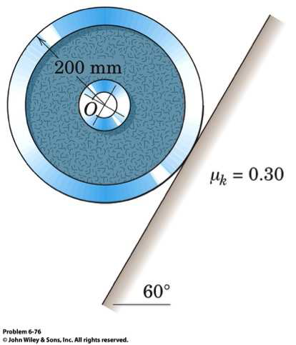

Problem 2. (25 Points)
The double pulley consists of two wheels, which are attached to one another and turn at the same rate. The pulley has a mass of 15 kg and a radius of gyration k_{O} = 110 mm.
If the block at A has a mass of 40 kg, determine the speed of the block in 3 s after a constant force is applied to the rope wrapped around the inner hub of the pulley. The block is originally at rest. Neglect the mass of the rope.
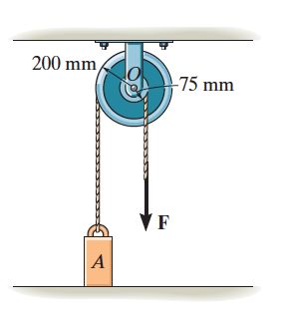

Problem 3: (25 Points)
The system is released from rest in the position shown. Calculate 1) the tension T in the cord and 2) the acceleration a of the 30 kg block. The small pulley attached to the block has negligible mass and friction.
.

Problem 4: (25 Points)
The 10 kg double wheel with radius of gyration of 125 mm about O is connected to the spring of stiffness k=600N/m by a cord which is wrapped securely around the inner hub. If the wheel is released from rest on the incline with the spring stretched 225 mm. calculate the maximum velocity v, the center O reaches during the ensuing motion. The wheel rolls without slipping.

