Ph.D. Qualifying Examination

Materials Science

Spring 2018

Notes:
- There are a total of 5 problems.
- Time allowed: 2.5 hours.
- Exam is closed book and closed-notes (one sheet of formulas is allowed)
- Problems count 20 points each (total=100 points).
- Show your work on these exam sheets. (Add additional sheets, if needed.)
- You may use a calculator.
- Laptops and cell phones are not allowed.

1. What is the purpose of the filler phase in a metal, polymer, and ceramic matrix composite, respectively?

2. Using the isothermal transformation diagram for an iron–carbon alloy of eutectoid composition (shown below), specify the nature of the final microstructure (in terms of microconstituents present and approximate percentages of each) of a small specimen that has been subjected to the following time–temperature treatments. In each case assume that the specimen begins at 760°C (1400°F) and that it has been held at this temperature long enough to have achieved a complete and homogeneous austenitic structure.
- Cool rapidly to 400°C (750°F), hold for 2 s, then quench to room temperature.
- Rapidly cool to 600°C (1110°F), hold for 4 s, rapidly cool to 450°C (840°F), hold for 10 s, then quench to room temperature.

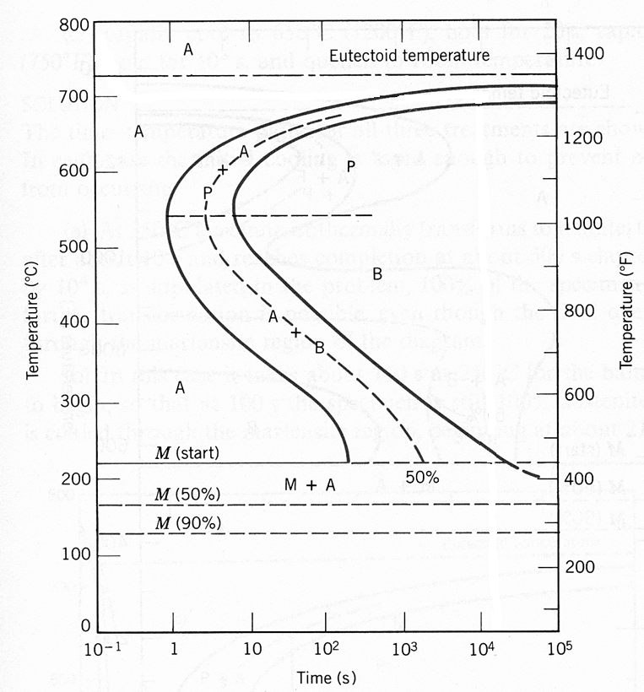

3. The atomic weight, density, and atomic radius for three hypothetical alloys are listed in the following table. For each, determine whether its crystal structure is FCC, BCC, or simple cubic and then justify your determination.

Alloy Atomic Weight Density Atomic Radius
(g/mol) (g/cm³) (nm)

A 77.4 8.22 0.125
B 107.6 13.42 0.133
C 127.3 9.23 0.142

4. A cylindrical 1040 steel rod having a minimum tensile strength of 865 MPa (125,000 psi), a ductility of at least 10%EL, and a final diameter of 6.0 mm (0.25 in.) is desired. Some steel stock of diameter 7.94 mm (0.313 in.) that has been cold worked 20% is available. Describe the procedure you would follow to obtain this material. Assume that 1040 steel experiences cracking at 40%CW.

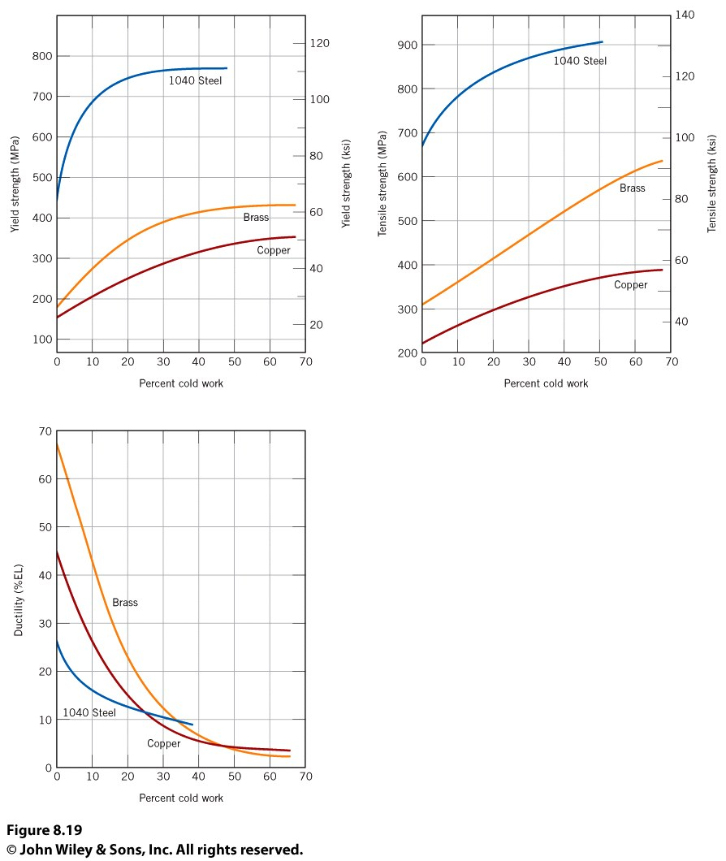

5. What is material of your choice that meets the following considerations? You answer should not refer to a general class of material (i.e., metals, polymers, ceramics, composites) but rather to specific materials and/or composites that meet the criterion.

a) High strength/weight, high modulus/weight, relatively ductile, and relatively inexpensive.

b) Strong but not brittle. Can operate at ~1000° C.

c) Very high strength per weight and relatively inexpensive.

d) Ultra-high stiffness per weight.

