Ph.D. Qualifying Examination

Materials Science

Fall 2018

Notes:
- There are a total of 4 problems.
- Time allowed: 2.5 hours.
- Exam is closed book and closed-notes.
- Problems count 25 points each (total=100 points).
- Show your work on these exam sheets. (Add additional sheets, if needed.)
- You may use a calculator.
- Laptops and cell phones are not allowed.

1. Show that the atomic packing factor for the BCC crystal structure is 0.68.

2. A cylindrical rod of brass originally 10 mm in diameter is to be cold worked by drawing. The circular cross section will be maintained during deformation. A cold-worked tensile strength in excess of 380 MPa and a ductility of at least 15 %EL are desired. Furthermore, the final diameter must be 7.5 mm. Explain how this may be accomplished.

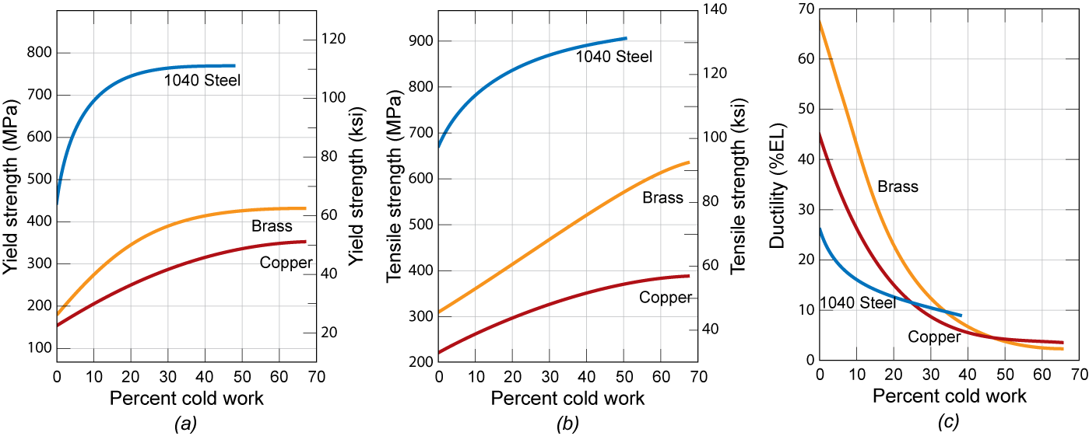

3. The following represents the phase diagram for an iron-cementite alloy of hypereutectoid composition.

- On the schematic, write down the name of the present phases in the 5 regions and draw the microstructure for each of the three g, h, and i points.

- For point i (right below the eutectoid line), what are the weight fractions and carbon content in the pro-eutectoid and eutectoid phases; carbon concentration in cementite is 6.7 %.

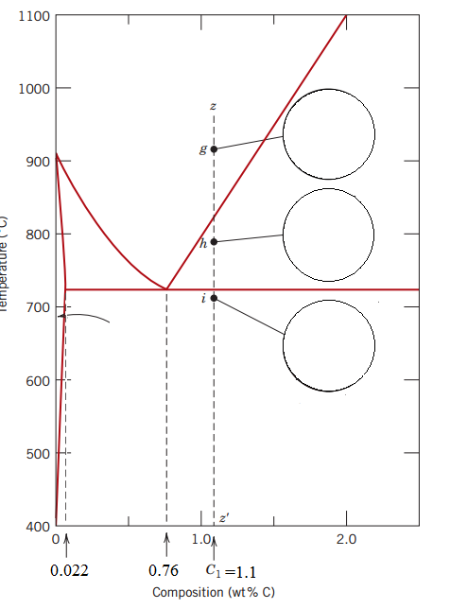

4. a) What are the different steel microstructures that can be achieved by cooling austenite at different rates?
b) rank these microstructures in terms of mechanical strength and justify your ranking in terms of dislocation movement.

